CCaNNI Education Group

Non Critical Care Nurses- Upskill training in Response to COVID-19 Pandemic.

Both regionally, and nationally, the CaNNI Lead Nurse Group have consistently led and developed programmes and resources to support Critical Care Nurse learning in Clinical Practice. This learning support and guidance has always been pragmatic, dynamic and responsive to the changing needs of the service.

Historically in 2010 in response to H1N1 Pandemic the CCaNNI Lead Nurse Group developed learning resources such as Flashcards and a Practice Framework to support Non Critical Care Nurses in Critical Care. As commensurate with CCaNNI Objectives these learning resources are updated and reviewed in line with Evidence Based Practice.

The most recent review of Learning Resources for Non Critical Care Nurses practising, under supervision, in Critical Care, had been in 2019; where CCaNNI Flashcards were updated and a new CCaNNI Upskill Programme was piloted (see Appendix 1).

The content of the Upskill Programme was based on a CCaNNI Questionnaire distributed to Perioperative Units around the region. Based on these responses CCaNNI Education Sub-Group devised a Pilot Study Day to support Perioperative Nurses to work in Critical Care under the supervision of an experienced Critical Care Nurse.
The objectives of the Upskill Study Day were to:

• Explain the roles and responsibilities of the non- ICU nurse in Critical Care
• Input basic nursing documentation onto the Critical Information System in ICU
• Outline the Ward Routine in Critical Care and list Bedside Safety Checks
• Perform a Head to Toe Assessment
• Have an awareness of Airvo, Ventilation and Non-Invasive Ventilation
• Determine basic ECG recognition and intervention
• Describe the care of Central and Arterial lines. And perform basic arterial blood gas analysis.
• Have an awareness of ICU medications and administration.

The Study Day included blended educational methodologies including lectures, seminars and skills stations based on the CCaNNI Flashcards and were very well evaluated (see Appendix 1).
The complete CCaNNI Upskill Programme and Learning Materials were therefore shared with CCaNNI members and essentially available for each Trust to adapt for bespoke local learning requirements.
In addition 2000 Pocket Books ‘A Tool for the Assessment of the Acutely Ill Adult’ (2020) were sourced from the Lancashire and Cumbria Network and distributed to Critical Care Areas across the five Trusts.

In direct response to the COVID -19 Pandemic, each Critical Care Unit in NI has upskilled staff to enable them to deliver safe, high quality patient care in Critical Care.

Phase 1:- Upskill Training of Non Critical Care Nurses in Response to COVID-19 Pandemic

March 2020- May 2020

In total there were 1103 Non Critical Care Nurses (Headcount) who had received Upskill Training by April 10th 2020.

As illustrated in the table below the number of staff who had been trained assured commissioners and providers that there was sufficient Non Critical Care Staff upskilled to work safely in Critical Care under supervision.

The training continued up until June 2020.

Upskill Training completed by NCCN’s (HC)
Alt | SWAH | Antrim | Causeway | CAH | BCH | MIH | RICU | CSICU | Ulster | Total
107 | 25 | 120 | 30 | 110 | 630 |  |  |  | 81 | IIO3

Phase 2 :- CCaNNI ’Nursing Practice Skills for Registered Nurses caring for Adult Critical care Unit Patients during Critical Care Escalation’ version 5 (March 2020)- sign off
The amount of Continuous Professional Development hours awarded are outlined below:-
- NCCN training 2½ hours with an additional 7½ hours for completing the Skills Booklet without exposure to a Critical Care Patient and up to a maximum of 56 hours on completion of Skills Booklet.
- CCN up to a maximum of 56 hours for teaching and supervision of NCCN.

A CCaNNI certificate was has been developed for both the NCCN and CCN, and it was thought that this would also help to value both cohorts significant contribution to the COVID-19 response.
There is heightened local, regional and national interest in Critical Care Nursing including education and career development.

Next Steps:-

On Line Resources TBD.

Evaluation

Report on Learning Resources Update to Support Perioperative Nurses Deployed to Critical Care During Escalation 2019.

Background
In the Regional Escalation Plan (2017), it is annotated, that in direct response to an increase in demand of Critical Care Capacity augmentation of nurse staffing may be obtained from areas such as Theatres/ Recovery, as outlined in local policy. Accordingly, redeployed staff would practice under the supervision of experienced Critical Care staff and any prerequisite training would be facilitated by respective Trusts.
Towards the end of 2017 and the beginning of 2018 there was a sustained period of Regional Escalation in Critical Care, comprising of twenty nine days. During this period it was reported that beds were closed within the system daily (Critical Care Escalation Report 2018) and one of the factors attributed to this was a lack of appropriately trained staff.
Although historically CCaNNI, in 2009 in response to Pandemic Flu, had developed resources e.g. Flashcards to support the redeployment of non- Critical Care Staff into Critical Care, in times of escalation, it was recognised that these may need to be reviewed and updated in alignment with changes in clinical practice.
Methodology
In keeping with andragogy (Knowles 2005) it was agreed that the cohort of nurses most likely to be deployed to Critical Care, in times of escalation, i.e. Perioperative Nurses should perhaps be given the opportunity to suggest what resources/ learning would support them in Critical Care Practice.
A questionnaire was therefore designed and circulated, where locally appropriate, for regional perioperative staff. In total forty one completed questionnaires were returned.

Results
The majority of respondents indicated that they would benefit from a study day in Critical Care, facilitated experience in Critical Care and Hardcopies of aide memoires to support them in the Intensive Care Environment (see Table 1).
Table 1
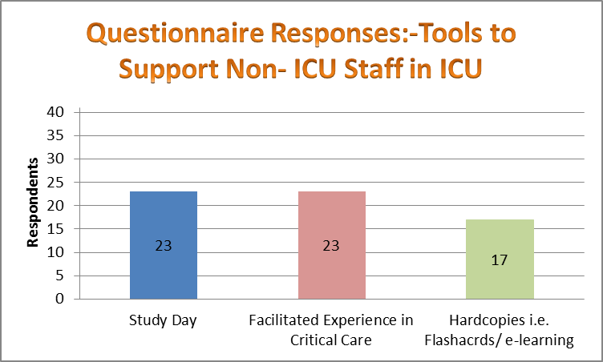
Results from the questionnaire also listed the areas where Perioperative Nurses considered they needed training in (see Table 2).
Table 2
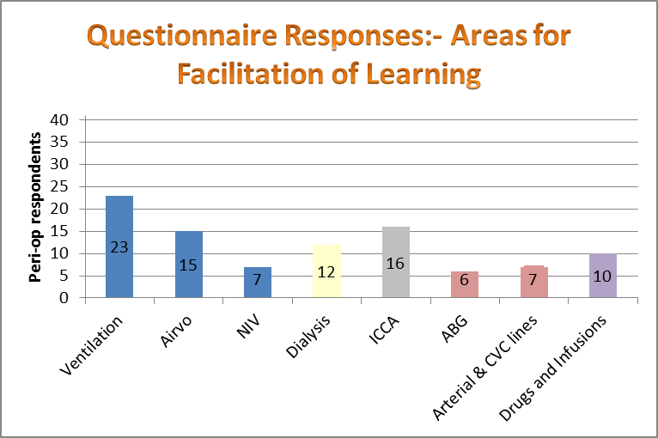

Recommendations
In response to the questionnaire, and discussion from the Senior Lead Nurse Group, the first area of focus was to review and update legacy aide-memoires i.e. Flashcards to support the non- ICU nurses in Critical Care. The priority was given to the Flashcards as this would also form the basic curriculum for a proposed Critical Care Study Day for non-ICU nurses.
The Flashcards were reviewed and updated by the Education Sub-Group and ratified by the Senior Lead Nurse Group, please see attached.

Following on from this the Education Sub-Group devised a Pilot Study Day on the 15th of November to support Perioperative Nurses to work in Critical Care under the supervision of an experienced Critical Care Nurse.
Please note haemofiltration was not included in the programme given the specialist nursing skills and training required for this treatment
The Study Day was facilitated by Senior Critical Care Nurses’ who lead on Education and Training within their respective Trust’s and was delivered in the Ulster Critical Care Training Facility. There were eighteen attendees from three out of five HSC Trusts.
The objectives of the Study Day were to:
- Explain the roles and responsibilities of the non- ICU nurse in Critical Care
- Input basic nursing documentation onto the Critical Information System in ICU
- Outline the Ward Routine in Critical Care and list Bedside Safety Checks
- Perform a Head to Toe Assessment
- Have an awareness of Airvo, Ventilation and Non-Invasive Ventilation
- Determine basic ECG recognition and intervention
- Describe the care of Central and Arterial lines. And perform basic arterial blood gas analysis.
- Have an awareness of ICU medications and administration.
The Study Day included blended educational methodologies including lectures, seminars and skills stations based on the CCaNNI Flashcards below.
Please see some of the teaching materials listed below.
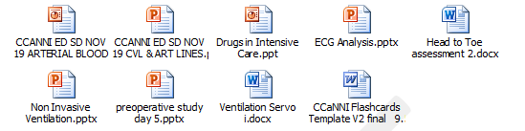

Sister Lorna Whitfield CSICU RVH Sister Gail Quigley ICU Altnagelvin

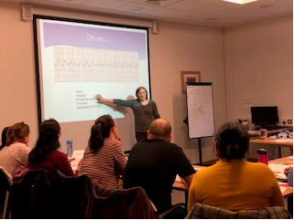
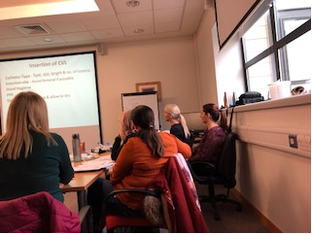
Sister Lianne Humphries ICU Ulster Sister Siobhan Jasztal ICU Craigavon
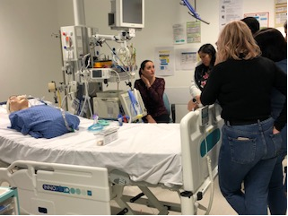
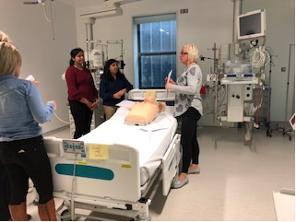

In line with Kolbs (1984) Experiential Learning Cycle the learning environment facilitated simulation areas to encourage the learner to have practical experience with the nursing skills being taught. Facilitators encouraged active engagement with learners throughout the programme.

Evaluation
All attendees positively evaluated the Study Day (see Table 3).
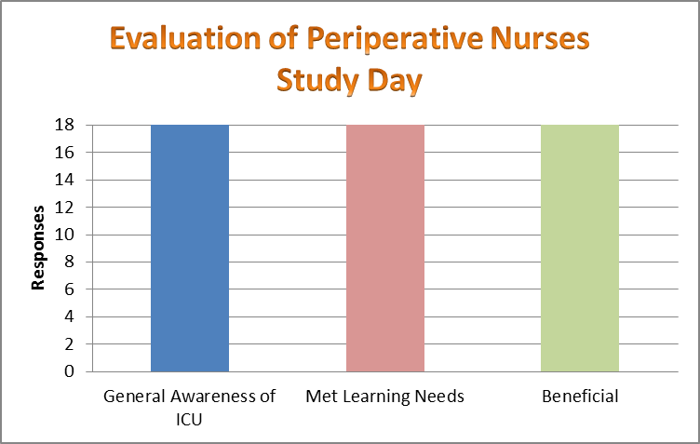
Some of the evaluations also stated the following:-
‘Extremely beneficial- I feel it gave me more insight into Critical Care and has given me the confidence to work there.’
‘Liked interactive workshop approach, easy to ask questions in smaller groups, relaxed environment.’
‘Every topic was very important, great learning.’
‘The programme more than covered my learning needs… should be made mandatory for staff working in this area.’
‘Excellent study day was well worth the journey, very relaxed and enjoyable, thank you.’
‘Well organised.’
‘Liked the range of different speakers.’
‘I have gained new knowledge and skills and will be able to carry them through my department and become more confident in working with HDU, ICU patients.’
Conclusion
In line with the Regional Escalation Plan (2017) CCaNNI Senior Lead Nurse Group has reviewed and updated legacy aide-memoirs i.e. Flashcards and designed and positively evaluated a bespoke Critical Care Study Day to support the non-ICU nurse in Critical Care.
The Flashcards have been disseminated to all Senior Lead Nurses for Local adaption/modification.
The programme and speakers presentations can be shared throughout the network and CCaNNI can assist in whichever way is most practicable for respective Units.
CCaNNI would advise that staff are given opportunities to consolidate their learning and practice associate skills under the supervision of a trained Critical Care Nurse in their respective Critical Care Unit.
Please contact Geraldine.brennan@hscni.net for further information.

Acknowledgements
Facilitators:-
Sister Louise Boreland ICU Causeway
Sister Sylvia Coulter ICU Antrim
Sister Lianne Humphries ICU Ulster
Sister Lorna Whitford CSICU RVH
Sister Siobhan Jasztal ICU Craigavon and Daisy Hill
Sister Gail Quigley ICU Altnegelvin
Venue:- Ulster Critical Care Training Suite

References
CCaNNI (2017) Regional Escalation Plan For Adult Critical Care.
CCaNNI (2018) Critical Care Escalation Report.
Knowles, Malcolm; Holton, E.F; Swanson, R.A (2005) The Adult Learner: The definitive classic in adult education and human resource development (6th ed) Burlington, MA:Elsevier.

